HAIR: BROWN EYES: BROWN HEIGHT: 5’8” WEIGHT: 190 VOCAL: E♭3 – C6
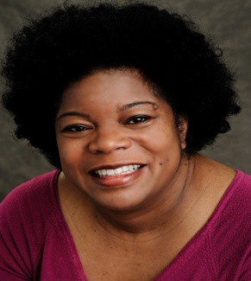
FILM/TELEVISION:
“Lemon Drop” Patrice dir: Max Bowens
https://vimeo.com/66675814

“Addicted to the Life: #109” Bank Teller Investigation Discovery

THEATER:
“Avenue Q” Lucy the Slut Silhouette Stages
“Hairspray” Motormouth Maybelle Howard County Summer Theatre Nominated for Maryland Theater Guide’s “Best Performance, Supporting Actress in a Musical”, 2012
“Oraculous” Chorus Mistress Salt Luck Arts (w/Mobtown Players)

“Crime and Pun-ishment” Ace Reporter/Trish Fish Murder Mystery Company (improv)

“Of Sound Mind & Dead Body” Mabel Velcro-Doowie Murder Mystery Company (improv)

“Murdercastle” Madame Opticon Baltimore Rock Opera Society

“He’s Not Your Soulmate 2” Gloria (lead) CMR Productions (showcase)

EDUCATION/TRAINING:
B.A. Psychology, Certificate in Theater Princeton University
Private Vocal Coaching Michael Tan
SPECIAL SKILLS:
Singing (mezzo- soprano; jazz, pop, choral, a capella); conversational French and Spanish; can read German and Italian; voice-over/narration; dance experience (ballet, jazz); ice skating; knitting; mental health professional and certified mediator

