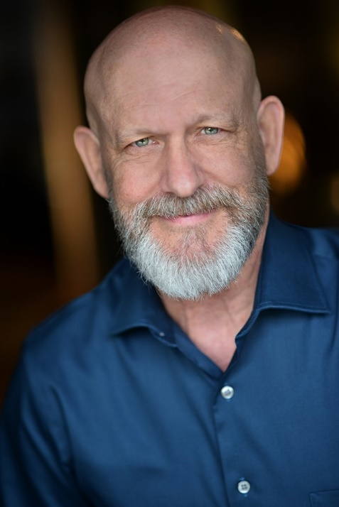
FILM
Meetings Mr. Guthrie Blue Wave Productions
Melvin Williams Detective Wineke Da Vision Pictures (Supporting)
Life in the Game
SPECIAL SKILLS/SPORTS
Athletic, Bowling, Pool, Darts, Swimming, Manual Transmission, Draftsman,
Authentic Southern Accent, Proficient on Zoom, and WebX Platforms,
Buddy Holly Enthusiast.

*Video Reel Upon Request
THEATER
The Importance of Being Earnest Merriman Mt. Airy Players, MD
Fool For Love Eddie Silver Spring Stage, MD
Dracula Renfield Foundry Players, DC
TRAINING
Drama Workshop Mary Beth Wise Theater Lab/Washington, DC
Intro to Acting George Grant Theater Lab/Washington, DC
Voice and Speech Tonya Beckman Theater Lab/Washington, DC
Monologue Coaching Mary Lincer Washington, DC
INDUSTRIAL/CORPORATE
John Hopkins Simulation Center Multiple Roles Filmed Training
UMB/School of Nursing Multiple Roles Filmed Training
G.W. Univ/Simulation Center Multiple Roles Filmed Training
Towson Univ/School of Nursing Tom Moore/Sam Goldburg Student Training
Kirkland and Ellis Various Roles Mock Trial/Deposition
TELEVISION
Panic 911 “Graveyard Dead” Billy Dean Riley I.D. Channel (Lead)
Evil Twins “All American Killers Wrestling Coach I.D. Channel (Supporting)
Mental Health Minutes Numerous Speaking Roles Mont. County Cable Channel 21
George Washington Carver Nicholas Longworth National Park Service (Day Player)
Evil Twins “Twisted Sister” Detective I.D. Channel (Day Player)
Who the Bleep Did I Marry? Detective I.D. Channel (Day Player)
House of Cards Funeral Home Director Netflix (Day Player)
CONTACT INFORMATION
thantis2013@yahoo.com
443-622-2034
VITAL STATISTICS
HEIGHT: 5’-8”
WEIGHT: 160 lbs
HAIR: BROWN/SHAVED
EYES: GREEN
AGE RANGE: 40-65 YEARS
BILL JONES

